**Primitive Resentment GDD**

Sebastian Biala-Learmonth | Timothy Hinshelwood | William Beaven | Preston Minuto

Project Overview 2

Game Description: 2

Market Analysis 2

Persona 2

Target Market 3

Design Pillars 3

Targeted Platform 3

Competitor Analysis 4

Mechanics List 6

Interactive Objects 6

Inventory System 6

Dialogue Boxes 6

Gated Objects and Doors 6

Keypad Entry 7

Randomised String Display 7

Area Transitions 7

# Project Overview

## Game Description:

Primitive Resentment is a point and click adventure game based on the short story ‘Primal Fury’ by Myles Blasonato. The game has players exploring an abandoned facility to uncover the many dark secrets it holds, while also being comedic in tone, with the juxtaposition between serious intensity and absurd comedy being the aesthetic the game revolves around. The game intends to blend elements of mystery and horror with some influence from the campy concepts of b grade movies to further solidify this aesthetic, grounding the more ridiculous aspects as to not make them feel totally out of place. Furthermore, the game also intends on conveying the way in which deeper, more complex themes can be portrayed within a comedic backdrop and represent that something doesn’t have to be a consistently solemn, humourless experience to be a narrative that’s engaging and covers darker themes.

# Market Analysis

## Persona

Primitive Resentment is a game built around the below persona of Artsy Andy, and is what informs the design philosophy and target market of Primitive Resentment: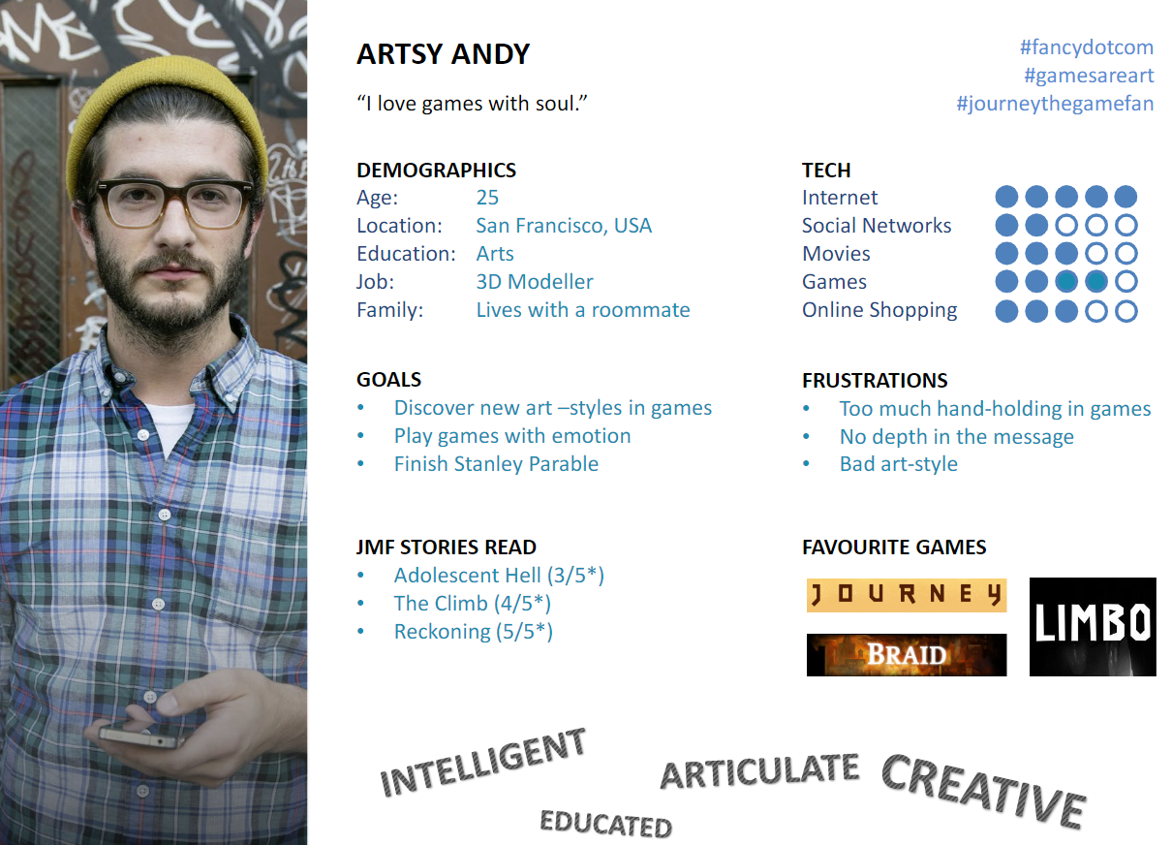

## Target Market

Due to Artsy Andy being the targeted brief for Primitive Resentment, the narrative elements of the game must be prominent and convey a story with a degree of depth and meaning. This prominent focus on narrative should be paired with some form of unique art style to further engage the people who like the side of games that make an attempt at being more ‘artistic’. The violent nature of the source material combined with the more serious themes that are being explored make the logical target market of the game to be a mature audience that is more prepared to deal with instances of disturbing subject matter. While this provides freedom in the severity of imagery that can be shown, lessening the potential of sugar-coating any message being presented, careful considerations must be made to ensure that the game feels purposeful in every aspect in order to not overpower one side of it too much. The initially contradictory nature of making a comedic game for an artsier audience further requires a meticulous approach to designing Primitive Resentment, both ensuring that the comedy never feels overly random to the point of meaningless absurdity, while also having a multifaceted narrative that can be further tied into an overarching artistic theme.

# Design Pillars

**Juxtaposition –** To provide the game with an overarching theme, each aspect of it needs to be tied to the concept of juxtaposition. Everything from the art, to the narrative, to even the sound effects need to strike a balance between starkly different ideas while blending together into something cohesive.

**Extremity –** While remaining cohesive, Primitive Resentment’s presentation further revolves around excess, both in terms of the heavily absurd comedy, and the brutality of many aspects of the narrative, in order to evoke the tone of many old, b-grade horror movies.

**Narrative Focus –** All aspects of the game must serve the core narrative that is portrayed, consistently revealing new plot points and further informing the player of the game’s setting while they are exploring the facility and completing puzzles.

## Targeted Platform

The point and click adventure is a game genre best suited to PC (Windows, Mac, Linux), as they are best suited to the keyboard and mouse control scheme the platform offers, allowing the user to not be confined to the static speed and relative imprecision of a cursor on a console.

# Competitor Analysis

**Myst:**

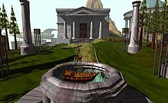

Summary

And old-school point and click adventure game that has the player exploring a mysterious island while solving puzzles in order to figure out how to escape back to reality.

Genre

Point and click adventure, puzzle

Relevance

The genre and surface level goals of both Myst and Primitive Resentment are the same, tasking the player to explore and uncover a mystery about their setting, both in the same first person point and click style as well.

Platform

PC, Mac, iOS, Android, PlayStation, PSP, Nintendo DS, Nintendo 3DS, Sega Saturn, Philips CD-i

Points of Differentiation

The more strongly comedic aspects of Primitive Resentment, along with the presentation being far more focused on narrative rather than puzzles is enough to strongly set these two games apart and provide a reason for this to be developed.

**Deadly Premonition**

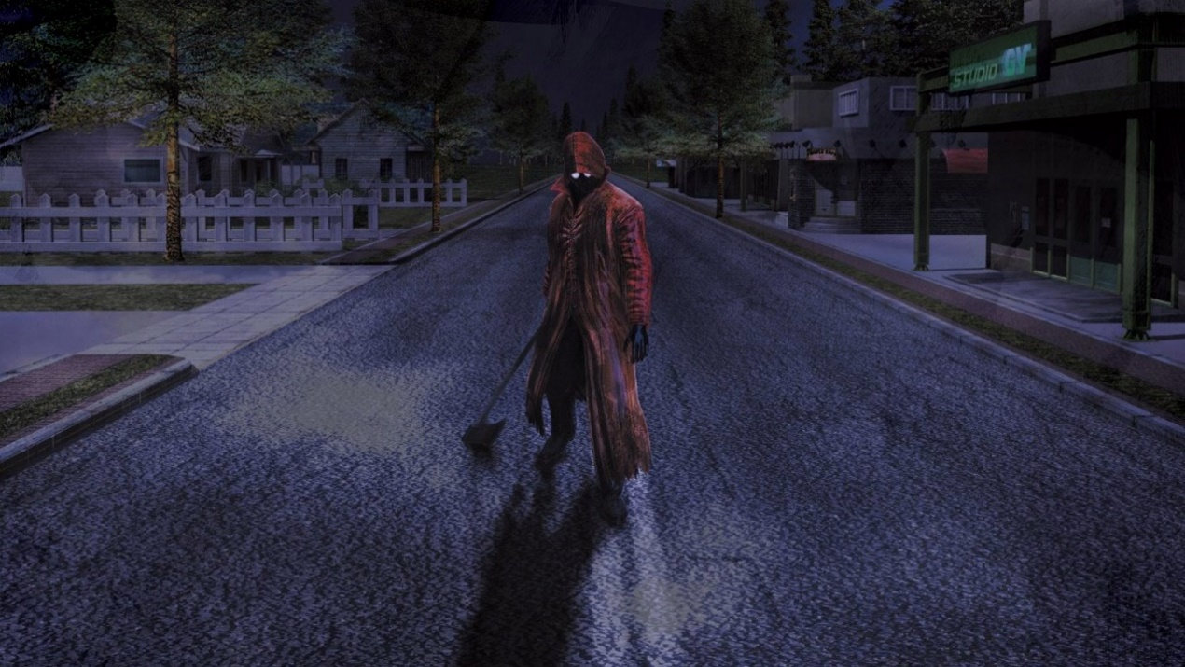

Summary

An open world, 3rd person survival horror game that has the player enact the role of FBI agent Francis York Morgan, who is assigned to investigate a series of mysterious murders suspected to have been instigated by the so-called Raincoat Killer in the equally idiosyncratic town of Greenvale.

Genre

Open world, 3rd person survival horror, action adventure

Platform

Xbox 360, PlayStation 3, Windows PC, Nintendo Switch

Relevance

Both games tackle a b-grade horror aesthetic that balances elements of absurdist comedy with darker themes and imagery. Furthermore, both games also involve uncovering the dark truths of a mysterious setting and hunting down a brutal serial killer.

Points of Differentiation

While thematically and stylistically the games share some common ground, the genre of game is entirely different, with the more slow paced, point and click take on this style of writing providing a different player experience. Furthermore, the pseudo-industrial/sci fi aesthetic of Primitive Resentment is strongly separated from the suburban setting that Deadly Premonition takes place in and provides a different type of atmosphere as a result, despite both delving into the territory of blending absurdity with cheap horror.

# Mechanics List

* Interactive Objects
* Inventory System
* Dialogue Boxes
* Gated Objects and Doors
* Keypad Entry
* Randomised String Display
* Area Transitions

## Interactive Objects

**Description:**

When the player clicks on an interactable object a dialogue box will appear to deliver story, information, or humour.

In some instances, the object will be placed into the player’s inventory for further investigation.

**Relation to Other Mechanics:**

Dialogue Boxes, Inventory System, & Gated Objects and Doors

## Inventory System

**Description:**

When the player hits the corresponding key, the inventory UI will appear. The player can then click on objects that are in the UI to make a dialogue box with further information appear.

**Relation to Other Mechanics:**

Dialogue Boxes & Interactive Objects

## Dialogue Boxes

**Description:**

When the player has interacted with an object or entered certain rooms, a UI element will appear with information and story. The player can click the “continue” button on the element to progress the dialogue.

In certain parts of the game, the final “continue” button will activate a new scene or area.

**Relation to Other Mechanics:**

Interactive Objects, Inventory System, & Area Transitions

## Gated Objects and Doors

**Description:**

There are certain doors in the game that require the player to pick up an item before progressing. When they interact with the door before picking up the item, it will display a dialogue box hinting at the required item for progression.

After acquiring the necessary item, a different dialogue box will say that the door has been opened and include some more story.

**Relation to Other Mechanics:**

Interactive Objects, Keypad Entry, & Randomised String Display

## Keypad Entry

**Description:**

The keypad obstacle produces visual and auditory feedback when the player clicks on buttons. When the player has clicked the buttons enough times, and a set amount of time has passed, then the player can pass through the next door.

**Relation to Other Mechanics:**

Randomised String Display & Gated Objects and Doors

## Randomised String Display

**Description:**

In the keypad obstacle, when the player clicks the button enough times some dialogue will display on the interactive desk. This dialogue is taken from an array of different responses at random.

**Relation to Other Mechanics:**

Keypad Entry & Gated Objects and Doors

## Area Transitions

**Description:**

When the player clicks on doors, the canvas elements and camera relating to the previous room will be disabled whilst the new rooms parts will be activated.

In certain instances this will trigger dialogue or an event instead.

**Relation to Other Mechanics:**

Dialogue Boxes

Dynamics

The way the narrative experience is conveyed throughout the game, where contextual detail and the story is slowly presented to the player as the game goes on, makes the dynamic of exploration emerge throughout. The mystery nature of the story lends itself to this dynamic, with the inventory interaction further contributing to this by providing additional information, the setting becomes far more interesting and provides additional insight into its events. Because of this, the core dynamic of the game revolves around slowly taking in the world and examining everything, which is further reinforced by the visuals making it easy to understand what can be clicked and examined.

Aesthetics

Due to the conflicting tone of the source material “primal fury”, with its brutality being contrasted with the sense of absurdity brought to the table from its premise, Primitive Resentment subsequently results in a game with its focus being around the concept of juxtaposition. This permeates every aspect of the game to provide a unique narrative experience that serves to be both comedic and serious. This includes balancing dialogue jokes with darker material, ensuring that the comedy doesn’t become too overbearing, nor does the brutality feel as uncomfortable as it might have otherwise been. To further solidify this theme, the sound effects also find themselves to be a mix of more cartoonish ones and gruesome elements to give further weight to both styles of writing, and the artstyle combines 2D png images with largely 3D environments. Along with thematically fitting with the game, this has the functional effect of making it easy to tell what can be interacted with, reducing the possibility of “pixel hunting” from occurring, and being conducive to the dynamic of exploration and discovery that forms the core of the game.